Domain Name | Artificial Intelligence and Machine Learning (AIML)
Project Title | AI-POWERED DIGITAL EVIDENCE MANAGEMENT & ANALYSIS SYSTEM
Group ID | G03
Student Name (with roll no) | Snehal Supekar (BACO23130), Divya Salunke (BACO23150), Siddhi Thorat (BACO23164)
Guide Name | Mrs. P. P. Shevatekar

Abstract

The AI-Powered Digital Evidence Management & Analysis System is a web-based platform that securely manages and analyzes digital evidence using Artificial Intelligence and Machine Learning. It enables investigators to upload, organize, and preserve evidence while maintaining integrity through hashing and chain-of-custody tracking. The system uses the MERN stack for application development and AI/ML models for evidence classification, suspicious file detection, and text analysis. It reduces manual effort, improves forensic investigations, and provides faster, data-driven insights through an interactive dashboard and automated reports.

Problem Statement
Traditional digital forensic systems often face difficulties in securely managing, organizing, and analysing large volumes of digital evidence. This project aims to develop an AI-Powered Digital Evidence Management & Analysis System that uses AI/ML techniques to classify, analyse, and identify relevant or suspicious digital evidence while maintaining evidence integrity and chain of custody.

Objective/Motivation
- To securely manage and organize digital evidence with proper integrity and chain-of-custody tracking.
- To use AI/ML techniques to classify and analyze digital evidence and identify relevant or suspicious evidence.
- To reduce manual forensic effort and provide faster, intelligent insights through a centralized web-based platform.
- To generate automated forensic reports and provide investigators with clear, actionable insights from analyzed evidence.

Architecture Diagram
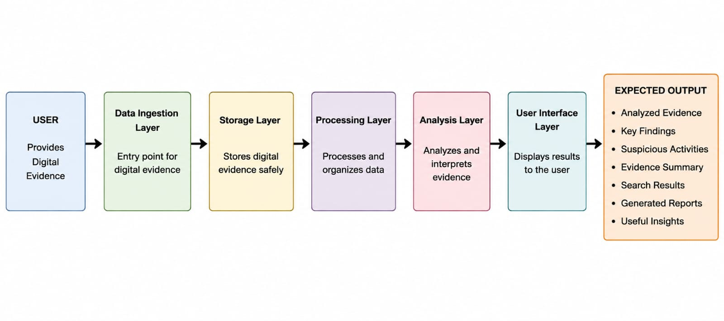

Advantages
- Provides secure and organized management of digital evidence with proper evidence tracking and integrity verification.
- Reduces manual effort by using AI/ML techniques for automatic evidence classification and analysis.
- Helps investigators identify relevant or suspicious evidence and provides useful insights for faster forensic investigation.
- Maintains chain of custody to improve the reliability and accountability of digital evidence.

Conclusion
The AI-Powered Digital Evidence Management & Analysis System provides a secure and intelligent platform for managing digital evidence. By combining AI/ML techniques with the MERN stack, the system can reduce manual effort, improve evidence organization, and assist investigators in identifying relevant or suspicious evidence. The proposed system aims to make digital forensic investigation faster, more reliable, and efficient through automated analysis, evidence tracking, and report generation.

Signature of Student Signature of Guide

